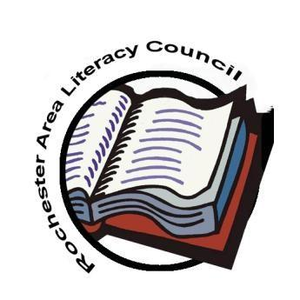
Rochester Area Literacy Council
New York State Reading Association
Membership Form
2020-2021

Name _________________________________________________________________

Home Address __________________________________________________________

City ____________________________________________ Zip __________________

Telephone ________________ E-mail _____________________________________
School District/College/Organization ________________________________________
Position ______________________________ Grade _______________________

International Literacy Association Member? •Yes • No ILA Number _________ Expiration Date _________

2020-2021 Membership Dues (Choose one)
◻ Professional $40.00 ($35.00 if received before 9/30/20)
◻ First-Year Teacher $20.00 ($15.00 if received before 9/30/20
(Attach a letter of verification from your district)

◻ Full-Time College Student $20.00 ($15.00 if received before 9/30/20)
(Attach a copy of your schedule: Undergraduate/12 hours Graduate/6 hours)

◻ Non-Employed Professional/Retiree $20.00 ($15.00 if received before 9/30/20)

◻ Paraprofessional/TA $20.00 ($15.00 if received before 9/30/20)
Note: Membership is not active until payment is received. A verification notice will be sent to the email provided once payment has been processed. RALC membership is effective July 1, 2020 through June 30, 2021.

Payment: ____ PayPal ____ District Purchase Order ____Check made out to RALC
For PayPal: Please add an additional $1.50 to your total to cover service fees. Link your payment to us by using our email rochesterarealiteracycouncil@gmail.com and “add a note” indicating that you are paying individual membership dues.

RETURN this form to: Rochester Area Literacy Council, PO Box 92333, Rochester, NY 14692

Online registration is also available at https://www.rochesterarealiteracycouncil.org/

