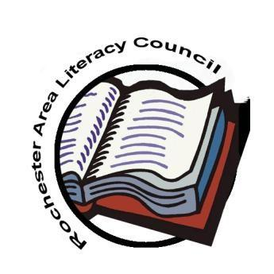
Rochester Area Literacy Council New York State Reading Association
GROUP Membership Form 2020-2021
District/Organization ________________________________________ Building_______________________________________________________
Name ___________________________________________________________  Home Addr. _________________________City ____________ Zip _________  Telephone________________ Position _____________________ Grade ______  E-mail ___________________________________________________________  ILA Member? Y/ N ILA Number ___________ Expiration Date __________ | Name ___________________________________________________________  Home Addr. _________________________City ____________ Zip _________  Telephone_______________ Position _____________________ Grade _______  E-mail __________________________________________________________  ILA Member? Y/ N ILA Number ___________ Expiration Date __________
Name ___________________________________________________________  Home Addr. _________________________City ____________ Zip _________  Telephone_______________ Position _____________________ Grade _______  E-mail ___________________________________________________________  ILA Member? Y/ N ILA Number ___________ Expiration Date ___________ | Name ___________________________________________________________  Home Addr. _________________________City ____________ Zip ________  Telephone_______________ Position _____________________ Grade ______  E-mail __________________________________________________________  ILA Member? Y/ N ILA Number ___________ Expiration Date __________
Name ___________________________________________________________  Home Addr. _________________________City ____________ Zip _________  Telephone_______________ Position _____________________ Grade ______  E-mail __________________________________________________________  ILA Member? Y/ N ILA Number ___________ Expiration Date __________ | PAYMENT OPTIONS:  ◻ PayPal: Please add an additional $1.50 to your total to cover service fees. Link your payment to us by using our email rochesterarealiteracycouncil@gmail.com and “add a note” indicating that you are paying group membership dues  ◻ Mail in payment: Make checks payable to Rochester Area Literacy Council and send to: Rochester Area Literacy Council  PO Box 92333  Rochester, NY 14692
Membership Dues (July 1, 2020 to June 30, 2021)
Professional GROUP Membership – Enroll a group 5 or more at $25.00 each
Please complete for each group member. For additional members, simply attach another form.

