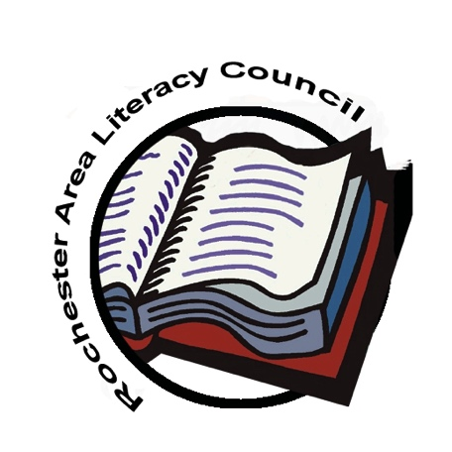
Rochester Area Literacy Council

Student Publishing Project

2019-2020 Theme:

So Runs the River

The theme of the eleventh Rochester Area Literacy Council’s (RALC) publishing opportunity, So Runs the River provides kindergarten through twelfth grade students with the opportunity to publish their written work relating to their creative and inventive imagination or their physical, social, emotional or cultural environment.
Student work may be completed at home or in school or some other organization. Specific topics and modes or genres of writing are open to the author’s purpose, perspective and voice. Entries submitted for consideration must be revised/edited with adult consultation to the publishable stage. A cover sheet and permission form must accompany each entry.
Student entries will be evaluated by a committee of local educators using guidelines provided in this packet and models of student work provided on the RALC web site. Selected entries will be compiled and published by the Rochester Area Literacy Council into a full color book. The author of a published entry will be awarded a complimentary copy of the book.

Timeline
February 20, 2020 | May be handwritten legibly/readable and mailed to Pat Martin, 1 Sylvan Knoll, Rush, NY 14543. May be sent digitally to pmartin1576@gmail.com or mbmorelle@gmail.com.
February 20, 2020 | Grades 9-12 entries and cover sheets must be sent electronically (Word file only) to pmartin1576@gmail.com. or mbmorelle@gmail.com.
March 2020 | Writing Clinic – online and face-to-face writing conversations
April 30, 2020 | Grades 3-8 entries and cover sheets must be sent electronically  (doc file only) to pmartin1576@gmail.com. or mbmorelle@gmail.com.
June 2020 | Published authors and their families will be invited to a celebration where each student will receive a free copy of So Runs the River.
Guidelines

- Guidelines and timelines must be followed for work to be accepted.
- The cover sheet must be legible (printed) and complete
- Entries must have a title and genre to be accepted.
- The standards and models describe the quality of work worthy of publication. The standards and models taken from past RALC publications can be found on the RALC website www.rochesterarealiteracycouncil.org .
- Writing may be any genre: song lyrics, memoir, satire, short story, narrative, informative, descriptive or persuasive essay, or poem. Acrostic poetry will not be accepted. Work must be original to the author.
- The entries for grades K, 1 and 2 will be typed by the publisher. Place student’s name on each page and number pages. Each entry may not exceed 2 pages.
- The entries for grades 3, 4, 5, 6, 7, 8, 9, 10, 11, 12 must be typed (Comic Sans, black, 12 point font, 1.5 spaced) electronically as a WORD doc. Place student’s name on each page and number pages. Name the file with the student’s last name, first initial and title of entry. Completed 3-5 entries should not exceed 3 pages; 6-12 entries should not exceed 5 pages.
- All entries must be revised, edited, and publication ready before submission. Publishable work is clear, organized and free of grammatical or technical errors. Final editing should be done with the adult who must sign the cover sheet.
- The editor may suggest some revisions and edits before the work is accepted. The editor may make minor revisions and edits before the work is published.
- Quotations and source material must be cited and documented. For information and guidelines about documenting resources, visit www.rochesterarealiteracycouncil.org.
- Multiple students’ submissions of a single class assignment will not be accepted.
- Entries may be done collaboratively by two students. When two students partner, a cover sheet for each individual must be completed. One complimentary book will be given to collaborative work.
- All living individuals mentioned by name or shown in photographs have given written permission for their name or likeness to appear in the publication.
- Any use of business logos or symbols has been approved by the company represented
- Address questions and concerns directly to Pat Martin: pmartin1576@gmail.com

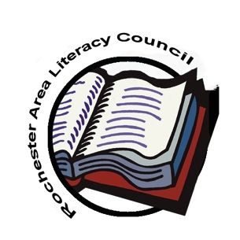
RALC Student Publishing Project 2019-2020
Cover Sheet and Publication Permission Form

This form must be printed, complete and legible (Please print). One form must accompany each entry.

Entry Title _______________________________________________ Genre _____________________

Student Name _______________________________________________________________________
(first) (last)
Teacher Name _______________________________________________________________________

Teacher’s Email_______________________________________________________________________

Adult Editor’s Signature_______________________________________________________________

Parent(s) Name _______________________________________________________________________

Parent(s) Email _______________________________________________________________________

Home Address _______________________________________________________________________

Grade ____ Building __________________________________________ District ________________

_____________________________________________________________________________________

I give permission to publish ________________________________________________’s writing in
Print student’s full name
the Rochester Area Literacy Council’s So Runs the River and to be featured on their website (rochesterarealiteracycouncil.org) I understand that
- The publishing committee will use the first name, grade, building and district to identify any student.
- The publishing committee has the right to edit text as needed for publication.
- All written work becomes the property of RALC and will not be returned.

__________________________________________________________ ____________________
Parent or guardian signature Date

